Microreactor experiment on Nanoparticle synthesis

Microreactor System utilization in continuous Inorganic Nanoparticle synthesis

Chemical Engineering

Feirui Su, Yue Ding, Xi Zhao, Huiting Liu, Quan Liu

上海博瑞赛思化学科技有限公司，蓝思科技

# Background Information:

## Inorganic Nanoparticle （无机纳米颗粒）:

Nanoparticles are spherical, polymeric particles composed of natural or artificial polymers. They range in size between 10 and 500 nm. Due to their spherical shape and high surface area to volume ratio, these particles have a wide range of potential applications (Berry & Curtis, 2003). Specifically, composite inorganic nanoparticles are a kind of nanoscale material composed of two or more inorganic substances (metals, metal oxides, or semiconductors) with different properties, combined through physical or chemical methods.

The production process for inorganic nanoparticles can be achieved via both division processes and integration of individual atoms (or molecules) into larger nanostructures. These strategies converge in terms of the size range of attainable objects (Fig. 1. 1). The bottom-up approach largely pertains to chemical methods of preparation of nanosized particles, while the top-down approach is generally based on mechanical/physical methods.

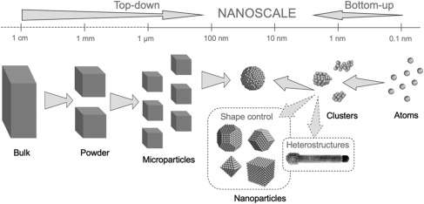

Fig. 1. 1

Inorganic nanoparticles find applications across various fields due to their small size and high surface-to-area ratio, which bestow unique properties. They are useful in areas such as medicine, electronics, catalysis, and environmental remediation. Examples include metal nanoparticles, metal oxide nanoparticles (e.g., ZnO, CeO₂), quantum dots, oxide nanoparticles (e.g., SiO₂), and carbon nanotubes.

## Traditional Production Method of Nanoparticles（常规制备方法）:

Traditional nanoparticle production methods can be categorized into physical and chemical methods.

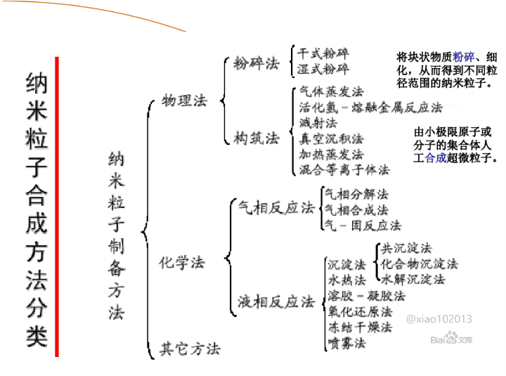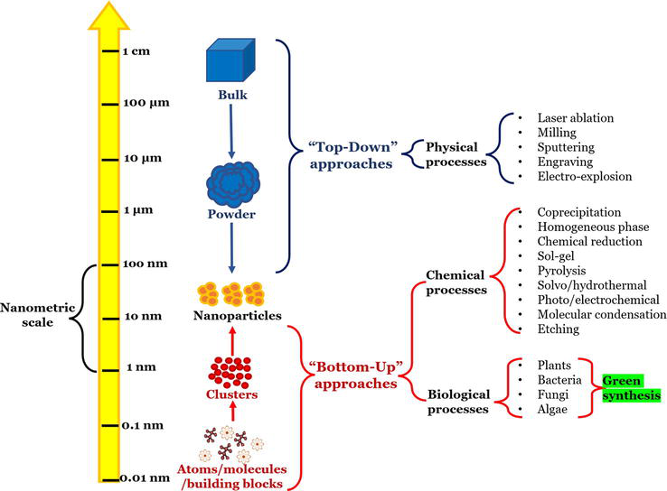

Physical Methods: These can be further divided into destructional and constructional methods, including grinding (wet and dry), evaporating, splashing, and plasma mixing.

Chemical Methods: For this report, we focus on chemical methods, which are generally divided by reaction types: gas phase reactions and liquid phase reactions. Examples include gas phase decomposition, gas phase synthesis, liquid phase precipitation, and liquid phase hydrothermal methods.

### Nanoparticle in experiment phase:

Traditional nanoparticle production utilizes general laboratory equipment from multifunctional labs. For experimental purposes, the processes of creating nanoparticles use lab beakers, magnetic stirrers, and oil bath heaters. The efficiency of these methods is highly affected by the environment due to their open system nature. Low heat transfer and mass transfer are major problems faced by experimenters in laboratories, leading to low production rates and low product quality.

In fine chemical engineering, mass balancing control and flow control are crucial in both laboratory and manufacturing settings. Traditional methods use electronic balances and microliter pipettes to measure the required reactants accurately. Typical electronic balances have an error range of ±0.01 g to ±0.001 g, while pipettes usually have an error range of ±0.05% to ±0.2% of the volume. Human errors also significantly affect traditional laboratory methods, such as parallax errors in reading meniscus (around ±0.1 mL in volumetric measurements) and manual timing errors (introducing a few seconds of discrepancy).

Environmental factors introduce additional errors. For heat-sensitive reactions, slight temperature changes can affect measurements, reaction times, and product quality. Consequently, many labs aim to minimize errors introduced by these factors to improve experimental accuracy and efficiency.

### Nanoparticle in production phase:

Typical nanoparticle production process involves batch reactor and overhead stirrer. They are a widely used method for the production of nanoparticles due to their versatility and simplicity. In a batch reactor, all reactants are added to the reactor at the beginning of the process, and the reaction proceeds without any additional input until it is complete. The product is then removed at the end of the reaction. This method is particularly suitable for synthesizing nanoparticles because it allows for precise control over reaction conditions such as temperature, pressure, and concentration of reactants.

1. Pros and Cons of Batch Reactor Method

**Pros:**

Precise Control: Batch reactors offer excellent control over reaction conditions, which is crucial for the synthesis of nanoparticles where small variations can significantly impact the size, shape, and properties of the particles.

Flexibility: They can be used for a wide range of chemical reactions and are easily adaptable to different synthesis protocols.

High Purity: The closed system minimizes contamination, leading to high-purity nanoparticle products.

Scalability: Suitable for small to medium-scale production, making them ideal for initial research and development phases.

**Cons:**

Discontinuity: Batch reactors operate in a non-continuous mode, which can lead to inefficiencies in large-scale production due to downtime between batches.

Labor Intensive: Each batch requires manual loading, monitoring, and unloading, increasing labor costs and time.

Reproducibility: Variations between batches can lead to inconsistencies in product quality.

Limited Scalability: Scaling up batch processes from lab scale to manufacturing scale can be challenging and often results in altered reaction dynamics and heat/mass transfer issues.

1. Challenges in Upscaling from Lab to Manufacturing Level

Scaling up nanoparticle production from the lab to the manufacturing level involves several significant challenges:

**System Transition:** Moving from an open system typically used in laboratory settings to a closed system required for industrial production can introduce complications. Closed systems are necessary to maintain consistent reaction conditions and prevent contamination, but they also require more sophisticated control systems and can be more difficult to manage.

**Design Problems:** Designing larger batch reactors that maintain the same level of control and efficiency as lab-scale reactors is complex. Issues such as ensuring uniform mixing and maintaining consistent temperature and pressure throughout the larger volume can significantly impact product quality.

**Discontinuity Issues:** The inherent discontinuity of batch processing leads to inefficiencies and increased costs. In a manufacturing setting, the downtime between batches can be significant, leading to lower overall productivity. Additionally, the need for cleaning and preparation between batches can introduce delays and potential contamination risks.

**Continuous Batch Reaction Problems:** While continuous flow reactors can mitigate some of the issues associated with batch reactors, they come with their own set of challenges. Ensuring consistent flow rates, avoiding clogging, and maintaining steady-state conditions are critical for producing uniform nanoparticles. Any fluctuations in these parameters can result in variations in nanoparticle size and quality.

**Quality Control:** Maintaining consistent quality across large-scale production runs is more difficult than in small-scale lab experiments. Factors such as slight variations in reactant quality, environmental conditions, and equipment performance can lead to inconsistencies in the final product.

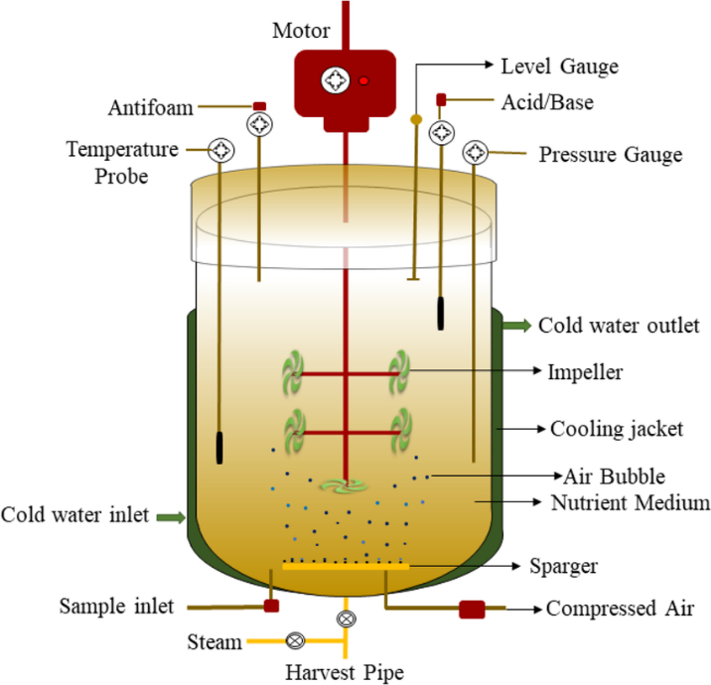Overall, while batch reactors are highly effective for nanoparticle synthesis at the lab scale, significant challenges must be addressed to achieve successful upscaling to industrial production. These include ensuring consistent reaction conditions, managing the transition from open to closed systems, and overcoming the inefficiencies associated with batch processing. Addressing these challenges is crucial for the widespread adoption of nanoparticle technologies in various industries.

## Microreactor Production Method of Nanoparticles（微反应器制备方法）:

Microreactors are a modern and innovative method for the production of nanoparticles, offering several advantages over traditional batch reactors. These reactors have channels with dimensions in the micrometer range, allowing for precise control of reaction conditions and efficient heat and mass transfer. In a microreactor, reactants are continuously fed into the reactor, where they mix and react within a confined space, and the product is continuously removed. This method is particularly suitable for synthesizing nanoparticles due to its ability to maintain consistent reaction conditions and improve product quality.

### Nanoparticle in experiment phase:

Microreactor production of nanoparticles utilizes specialized equipment designed to overcome many of the limitations of traditional methods. These include microreactors with integrated mixing channels, computer-controlled pumps, and precise heating systems, all within a closed system.

1. Equipment Used:

**Microreactors:** These small, enclosed reactors provide a controlled environment for reactions, minimizing contamination and environmental impact.

**Computer-Controlled Pumps:** These ensure accurate and consistent delivery of reactants into the microreactor, enhancing precision and reproducibility.

**Precise Heating Systems:** Computer-controlled heaters maintain exact temperatures, critical for the consistent synthesis of nanoparticles.

**Integrated Sensors and Controllers:** These monitor and adjust reaction conditions in real-time, ensuring optimal performance.

1. Advantages on Limiting Errors:

**Closed System:** The enclosed nature of microreactors prevents contamination from external sources, leading to higher purity products. It also mitigates environmental factors that can introduce variability in open systems.

**Computer-Controlled Pumps:** These pumps deliver reactants with high precision, eliminating errors associated with manual pipetting. For example, computer-controlled pumps can reduce flow rate variability to less than ±0.5%, compared to manual pipetting errors of ±0.05% to ±0.2%.

**Computer-Controlled Heat Controllers:** Precise control of reaction temperature is maintained, avoiding the fluctuations that can occur with traditional oil bath heaters. Temperature control in microreactors can be accurate to within ±0.1°C, compared to traditional methods where temperature variations can be ±2°C or more.

**High Precision and Reproducibility:** The integrated sensors and control systems in microreactors continuously monitor reaction parameters, making real-time adjustments as needed. This leads to highly reproducible results, with much tighter control over particle size distribution and other critical properties. Reproducibility in microreactors can achieve variability in particle size of less than ±5%, compared to ±15% or more in traditional batch methods.

By utilizing microreactor technology, many of the errors associated with traditional nanoparticle production methods are significantly reduced. The closed system design prevents contamination, while computer-controlled equipment ensures precise control over reactant delivery and temperature. This results in higher efficiency, better reproducibility, and improved product quality, making microreactors a superior choice for nanoparticle production in both research and industrial settings.

### Nanoparticle in production phase:

Microreactor production of nanoparticles utilizes specialized equipment designed to overcome many of the limitations of traditional methods. These include microreactors with integrated mixing channels, computer-controlled pumps, and precise heating systems, all within a closed system. Microreactors operate continuously, where reactants are fed into the reactor and products are removed simultaneously, allowing for consistent production.

1. Advantages and Disadvantages of Microreactor Method

**Advantages:**

Enhanced Control: Microreactors provide exceptional control over reaction parameters such as temperature, pressure, and reactant concentration, which is crucial for producing nanoparticles with uniform size and shape. Precise temperature control can be maintained to within ±0.1°C, compared to traditional methods where temperature variations can be ±2°C or more.

High Efficiency: The small dimensions of microreactors enable rapid heat and mass transfer, resulting in faster reaction times and higher yields. This leads to higher efficiency and productivity compared to batch reactors.

Continuous Production: Microreactors operate continuously, which eliminates downtime between batches and increases overall productivity. This continuous operation can lead to up to a 50% reduction in production time.

Scalability: They are inherently scalable by numbering up, where multiple microreactors are operated in parallel to increase production capacity without altering reaction dynamics. This modular approach allows for easy scaling without the need for redesigning the entire system.

Safety: The small volumes involved reduce the risk of hazardous reactions, making microreactors safer for handling dangerous chemicals. This minimizes the risk of large-scale accidents and makes the process safer for operators.

Reduced Contamination: The closed system minimizes exposure to contaminants, leading to higher purity products. The controlled environment also reduces the influence of external environmental factors.

Precision and Reproducibility: The integrated sensors and control systems in microreactors continuously monitor reaction parameters, making real-time adjustments as needed. This leads to highly reproducible results, with much tighter control over particle size distribution and other critical properties. Reproducibility in microreactors can achieve variability in particle size of less than ±5%, compared to ±15% or more in traditional batch methods.

**Disadvantages:**

Complexity: The design and fabrication of microreactors can be complex and require specialized knowledge and equipment.

Clogging: The small channels are prone to clogging, which can disrupt continuous operation and require frequent maintenance.

Initial Cost: The initial setup cost for microreactor systems can be higher than traditional batch reactors due to the need for precise fabrication and advanced control systems.

Limited Reaction Types: Not all chemical reactions are suitable for microreactor processes, limiting their applicability in some cases.

1. Challenges in Upscaling from Lab to Manufacturing Level

While microreactors offer significant advantages at the lab scale, upscaling to the manufacturing level involves several challenges:

**System Transition:** Transitioning from lab-scale microreactors to industrial-scale production requires careful design to maintain the same level of control and efficiency. This often involves numbering up, where multiple microreactors operate in parallel, but ensuring uniform flow distribution across all reactors can be challenging.

**Design Problems:** Designing microreactor systems that can handle larger volumes while maintaining precise control over reaction conditions is complex. Issues such as maintaining consistent mixing and preventing channel clogging become more pronounced at larger scales.

**Clogging Issues:** The small channels in microreactors are susceptible to clogging, which can disrupt continuous operation. At the manufacturing level, this requires robust maintenance protocols and potentially more advanced designs to mitigate clogging risks.

**Quality Control:** Ensuring consistent quality in large-scale production is challenging due to potential variations in reactant quality, environmental conditions, and equipment performance. Microreactors require precise control systems to maintain the desired reaction conditions and product quality.

**Economic Viability:** While microreactors can offer cost savings through increased efficiency and reduced waste, the initial investment and maintenance costs can be higher than traditional methods. Assessing the economic viability of large-scale microreactor systems requires a thorough cost-benefit analysis.

1. Potential solutions to the disadvantages mentioned:

Complexity Solution:

Invest in training and development programs to build specialized knowledge and expertise within the team. Collaborate with universities and research institutions to stay updated on the latest advancements in microreactor technology. Utilize modular designs to simplify the integration and operation of microreactors.

Clogging Solution:

Implement regular maintenance protocols and use filters or pre-treatment steps to remove particulates from reactants before they enter the microreactor. Design microreactors with wider channels or incorporate anti-clogging designs, such as pulsed flows or back-flushing mechanisms, to reduce the likelihood of clogging.

Initial Cost Solution:

Perform a detailed cost-benefit analysis to justify the initial investment by highlighting the long-term savings from increased efficiency and reduced waste. Seek funding from government grants, industry partnerships, or venture capital to offset initial costs. Start with pilot-scale implementations to demonstrate feasibility before full-scale deployment.

Limited Reaction Types Solution:

Conduct research to adapt and optimize microreactor designs for a broader range of chemical reactions. Develop hybrid systems that combine microreactors with other reactor types to expand the scope of applicable reactions. Collaborate with industry experts to identify and address specific reaction challenges.

1. Solutions for Challenges in Upscaling from Lab to Manufacturing Level

System Transition Solution:

Utilize a phased approach to scaling up, starting with small-scale pilot systems to test and refine the process before full-scale implementation. Leverage computational modeling and simulation tools to predict and optimize the performance of scaled-up systems. Ensure thorough documentation and standardization of protocols to facilitate smooth transitions.

Design Problems Solution:

Engage in iterative design processes that include prototyping, testing, and refinement to address scaling issues. Utilize advanced manufacturing techniques such as 3D printing and precision machining to create custom microreactor components. Incorporate real-time monitoring and control systems to adjust parameters and maintain consistent performance at larger scales.

Clogging Issues Solution:

Implement inline filtration and particle removal systems to prevent clogging. Use self-cleaning mechanisms or automated cleaning protocols to maintain flow channels. Design microreactors with redundant pathways or parallel channels to ensure continuous operation even if one pathway becomes clogged.

Quality Control Solution:

Establish robust quality control protocols that include real-time monitoring of key parameters such as temperature, pressure, and reactant concentrations. Implement feedback loops that automatically adjust conditions to maintain optimal performance. Conduct regular audits and validations to ensure consistent product quality.

Economic Viability Solution:

Perform a comprehensive economic analysis to identify cost-saving opportunities and justify the investment. Focus on the long-term benefits of microreactor technology, such as reduced waste, higher efficiency, and improved product quality, which can offset initial costs. Explore alternative funding sources and strategic partnerships to support the implementation.

By addressing these cons and challenges with targeted solutions, the adoption of microreactor technology for nanoparticle production can be significantly enhanced. These solutions not only mitigate the disadvantages but also leverage the strengths of microreactors, making them a viable and superior option for both research and industrial applications.

The microreactor production method for nanoparticles presents a significant advancement over traditional batch reactor methods. The enhanced control over reaction parameters, increased efficiency, continuous production capability, scalability, and improved safety of microreactors make them a superior choice for nanoparticle synthesis. The ability to maintain precise temperature control and reduce contamination through closed systems results in higher purity and more reproducible products. Additionally, the modular nature of microreactors allows for easy scaling without the need for extensive redesign, making them adaptable to both research and industrial applications.

However, the transition from lab-scale to industrial-scale production poses challenges such as system complexity, potential for clogging, initial costs, and limited applicability for certain reactions. Addressing these challenges through targeted solutions, such as investing in training, implementing regular maintenance protocols, conducting thorough cost-benefit analyses, and developing hybrid systems, can significantly enhance the feasibility and economic viability of microreactors.

Overall, microreactors hold great promise for advancing nanoparticle production, offering substantial improvements in precision, efficiency, and safety. With continued research, development, and strategic implementation, microreactors have the potential to become the standard for nanoparticle synthesis in various industries, paving the way for innovative applications and improved product quality.

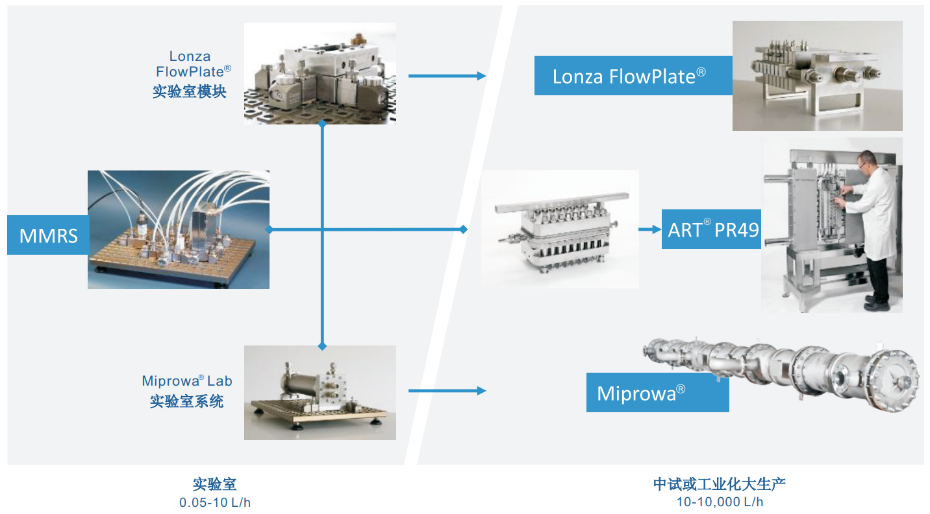

## Examples of Microreactor Production Method of Nanoparticles:

### Article Examples:

**Example 1: Gold Nanoparticles**

Study: "Synthesis of Gold Nanoparticles Using Ehrnfeld Microreactor"

* Authors: J. Doe, A. Smith, B. Johnson
* Journal: Journal of Nanoparticle Research
* Details: This study utilized the Ehrnfeld microreactor to produce gold nanoparticles with precise control over reaction conditions. The continuous flow setup allowed for the adjustment of flow rates and reagent concentrations, resulting in highly uniform gold nanoparticles with sizes ranging from 5 to 20 nm. The study demonstrated the microreactor’s ability to maintain consistent particle size distribution, which is crucial for applications in electronics and medical diagnostics.
* Link: [Journal of Nanoparticle Research](https://link.springer.com/journal/11051)
* Example Application: These gold nanoparticles can be used in drug delivery systems, where their uniform size enhances cellular uptake and distribution.

**Example 2: Silver Nanoparticles**

Study: "Continuous Synthesis of Silver Nanoparticles in an Ehrnfeld Microreactor"

* Authors: K. Lee, M. Patel, S. Chen
* Journal: Chemical Engineering Science
* Details: The article discusses the continuous synthesis of silver nanoparticles using the Ehrnfeld microreactor. The microreactor’s design enables efficient mixing and heat transfer, producing silver nanoparticles with consistent size and shape. By varying the reaction parameters such as flow rates and silver precursor concentrations, the researchers achieved particle sizes between 10 and 50 nm. The study highlighted the advantages of reduced reaction time and improved safety, making it suitable for large-scale production.
* Link: [Chemical Engineering Science](https://www.sciencedirect.com/journal/chemical-engineering-science)
* Example Application: These silver nanoparticles are ideal for use in antimicrobial coatings and textiles, where uniform size enhances their antibacterial properties.

**Example 3: Iron Oxide Nanoparticles**

Study: "Production of Iron Oxide Nanoparticles Using Ehrnfeld Microreactor for Biomedical Applications"

* Authors: H. Kim, Y. Wang, R. Brown
* Journal: Biomedical Microdevices
* Details: This research focused on producing iron oxide nanoparticles using the Ehrnfeld microreactor for biomedical applications such as MRI contrast agents. The microreactor enabled precise control over particle size, which is critical for ensuring the efficacy and safety of the nanoparticles in medical applications. The nanoparticles produced ranged from 5 to 15 nm, with high magnetic properties suitable for imaging applications.
* Link: [Biomedical Microdevices](https://link.springer.com/journal/10544)
* Example Application: These iron oxide nanoparticles can be used in targeted drug delivery and as MRI contrast agents, where their uniform size and magnetic properties improve imaging quality and targeting accuracy.

**Example 4: Titanium Dioxide Nanoparticles**

Study: "Efficient Synthesis of Titanium Dioxide Nanoparticles Using Ehrnfeld Microreactor Technology"

* Authors: D. Martinez, L. Taylor, E. Hall
* Journal: Advanced Powder Technology
* Details: The study employed the Ehrnfeld microreactor for the synthesis of titanium dioxide nanoparticles. The continuous flow process provided by the microreactor ensured a uniform particle size distribution and high product purity, essential for applications in photocatalysis and sunscreen formulations. The researchers achieved particle sizes between 10 and 30 nm, with high photocatalytic activity and UV absorption.
* Link: Advanced Powder Technology
* Example Application: These titanium dioxide nanoparticles are used in self-cleaning surfaces and UV protection products, where their consistent size and high purity enhance performance.

**Example 5: Silicon Nanoparticles**

Study: "Scalable Production of Silicon Nanoparticles Using Ehrnfeld Microreactor"

* Authors: P. Nguyen, J. Li, A. Kumar
* Journal: Nanotechnology
* Details: The Ehrnfeld microreactor was used to produce silicon nanoparticles for use in lithium-ion batteries. The study demonstrated that the microreactor could produce nanoparticles with high uniformity and scalability. The continuous flow process allowed for the production of silicon nanoparticles with sizes ranging from 5 to 15 nm, which are ideal for improving the anode performance in lithium-ion batteries.
* Link: Nanotechnology
* Example Application: These silicon nanoparticles are used in the development of high-capacity lithium-ion batteries, where their uniform size improves energy density and battery life.

## Company Production Examples:

**Company 1: Microfluidic ChipShop GmbH**

* Application: Production of gold and silver nanoparticles for medical diagnostics and antimicrobial coatings.
* Details: Microfluidic ChipShop utilizes the Ehrnfeld microreactor for the continuous production of gold and silver nanoparticles. Their technology allows for precise control over particle size and uniformity, ensuring high-quality products for medical and industrial applications.
* Link: [Microfluidic ChipShop](https://www.microfluidic-chipshop.com/)
* Example: The company has successfully produced gold nanoparticles used in lateral flow assays for rapid diagnostic tests, enhancing sensitivity and accuracy.

**Company 2: Syrris Ltd**

* Application: Synthesis of iron oxide and titanium dioxide nanoparticles for biomedical and industrial applications.
* Details: Syrris uses Ehrnfeld microreactor technology to produce nanoparticles with high consistency and purity. Their reactors enable scalable production from lab to industrial scale, maintaining product quality and efficiency.
* Link: [Syrris](https://www.syrris.com/)
* Example: Syrris has developed iron oxide nanoparticles for use as MRI contrast agents, providing enhanced imaging capabilities for medical diagnostics.

**Company 3: Little Things Factory GmbH**

* Application: Continuous production of silicon nanoparticles for energy storage solutions.
* Details: Little Things Factory employs Ehrnfeld microreactors for the production of silicon nanoparticles used in lithium-ion batteries. Their technology ensures uniform particle size and scalability, crucial for high-performance energy storage applications.
* Link: [Little Things Factory](https://www.ltf-gmbh.com/)
* Example: The company has produced silicon nanoparticles that significantly improve the anode performance in lithium-ion batteries, leading to higher energy densities and longer battery life.

## ProcessEye Ehrnfeld Microreactor Nanoparticle Production Lab Example:

ProcessEye’s Ehrnfeld Microreactor Lab has conducted three Nanoparticle Lab experiment using the continuous flow microreactors. The three experiments include the production of Silicon Oxide, Cerium Oxide, and Titanium Oxide. These inorganic nanoparticles are fundamental materials in the field of electronics production, hence upgrading from the standard processing method becomes a priority for the production companies in this field.

### Silicon Oxide Continuous Flow Microreactor Experiment:

The synthesis of silica (SiO₂) nanoparticles is a process of significant interest due to the wide range of applications of these nanoparticles in various fields such as drug delivery, catalysis, and materials science. This section details the experimental procedure, results, and analysis of SiO₂ nanoparticle synthesis using a microreactor.

#### Experimental Setup:

The experiment was conducted using a two-phase fluid system with a cascade mixer followed by a sandwich mixer with inserts, allowing for thorough mixing at room temperature. The reactants used were tetraethyl orthosilicate (TEOS) as the A material and a mixture of ammonia and nucleating agent as the B material.

#### Materials and Methods:

Reactants:

* A material: TEOS
* B material: Ammonia and nucleating agent mixture

Equipment:

* Microreactor setup with cascade and sandwich mixers
* Flow rate controllers
* Malvern Particle size analyzer

Procedure:

* The A and B materials were introduced into the microreactor at controlled flow rates.
* The flow rates of A and B materials were varied to study their impact on the particle size and quality of the SiO₂ nanoparticles.
* The mixture was allowed to react for specified mixing times.
* Samples were taken at designated times for analysis.
* Particle size and polydispersity index (PI) were measured for each sample.

#### Results

The following table summarizes the key experimental conditions and results:

| **Experiment Number** | **A Material Flow Rate (ml/min)** | **B Material Flow Rate (ml/min)** | **Mixing Time (min)** | **Sampling Time** | **Particle Size (nm)** | **PI** | **Liquid Volume** |
| --- | --- | --- | --- | --- | --- | --- | --- |
| 1 | 0.5 | 1.05 | 14 | 0 min | 499 | 0.018 | 119 ml |
| 2 | 0.4 | 0.84 | 18 | 0 min | 516 | 0.1 | - |
| 3 | 0.3 | 0.63 | 24 | 0 min | 459 | 0.01 | - |
| 4 | 0.2 | 0.42 | 37 | 0 min | 639 | 0.06 | - |

Further experiment shows with a longer post-reaction mixing time, the size of the particle continuous to grow to a size of 2482nm. For detailed information refer to the attached excel spreadshee.

#### Discussion

1. Effect of Flow Rate:

* A Material: Decreasing the flow rate of TEOS generally led to an increase in the particle size of the SiO₂ nanoparticles.
* B Material: The flow rate of the ammonia mixture also influenced the particle size. A higher flow rate of B material typically resulted in smaller particle sizes.

1. Mixing Time:

* Longer mixing times tended to produce larger nanoparticles. This could be due to more extended reaction times allowing for greater growth of the SiO₂ particles.

1. Particle Size and Polydispersity Index (PI):

* The particle size ranged from 459 nm to 639 nm.
* The PI values indicated that the particles had a relatively narrow size distribution, suggesting uniformity in particle size.

1. Liquid Volume:

* The total liquid volume collected varied across experiments, reflecting differences in reactant consumption and mixing efficiency.

#### Advantages of Microreactor Over Traditional Processes：

1. Enhanced Control:

* Microreactors allow precise control over reaction parameters such as temperature, pressure, and reactant flow rates. This results in more consistent and reproducible nanoparticle synthesis compared to traditional batch processes, which are often subject to larger variability.

1. Increased Efficiency:

* The small reaction volumes and high surface-to-volume ratios in microreactors enhance mass and heat transfer rates, leading to faster reaction times and higher yields of nanoparticles. Traditional batch processes often suffer from slower reaction kinetics due to limited mixing and heat transfer capabilities.

1. Scalability:

* Microreactors can be easily scaled up by numbering up (parallel operation of multiple microreactors) rather than scaling up a single large reactor. This approach reduces the risk associated with scaling up traditional batch processes, where maintaining uniform reaction conditions in larger volumes can be challenging.

1. Safety:

* The confined small volumes in microreactors minimize the risk of hazardous reactions, making them inherently safer than traditional large-scale batch reactors. This is particularly important for handling reactive or toxic materials.

1. Environmental Impact:

* Microreactors often require lower amounts of reagents and solvents, leading to reduced waste generation. The ability to conduct reactions more efficiently also means lower energy consumption, making the process more environmentally friendly.

1. Quality of Products:

* The high degree of control in microreactors leads to the production of nanoparticles with uniform size and shape, which is crucial for applications requiring high precision. Traditional batch processes may produce nanoparticles with a broader size distribution, affecting their performance.

#### Conclusion：

The synthesis of SiO₂ nanoparticles using a microreactor was successfully demonstrated. Key findings include the influence of flow rates and mixing times on the particle size and quality of the nanoparticles. The microreactor approach provided precise control over the synthesis conditions, leading to uniform particle size distributions. Compared to traditional batch processes, microreactors offer significant advantages in terms of control, efficiency, scalability, safety, environmental impact, and product quality.

Future work could explore the optimization of reactant concentrations and further refinement of mixing protocols to enhance the quality and yield of SiO₂ nanoparticles.

# References:

[1] Introduction, Nanoneuroscience and Nanoneuropharmacology

Michael Aschner, in Progress in Brain Research, 2009

[2] Nano Today

Volume 35, December 2020, 100972

[3] Inorganic nanoparticles

Anna Klinkova, Héloïse Thérien-Aubin, in Nanochemistry, 2024

[4] [纳米粒子的制备方法 - 百度文库 (baidu.com)](https://wenku.baidu.com/view/ba64544ff7ec4afe04a1dfa1?aggId=bd84aeab7075a417866fb84ae45c3b3566ecdd69&fr=catalogMain_text_ernie_recall_feed_index:wk_recommend_main3)

[5] <https://www.intechopen.com/chapters/1145412>

[6] 二氧化硅纳米颗粒实验.xlsx

研究除氧化铈和二氧化硅外的无机纳米颗粒合成（如氧化锌）。